Balkan MO 2017 Student Report (Sam Bealing)
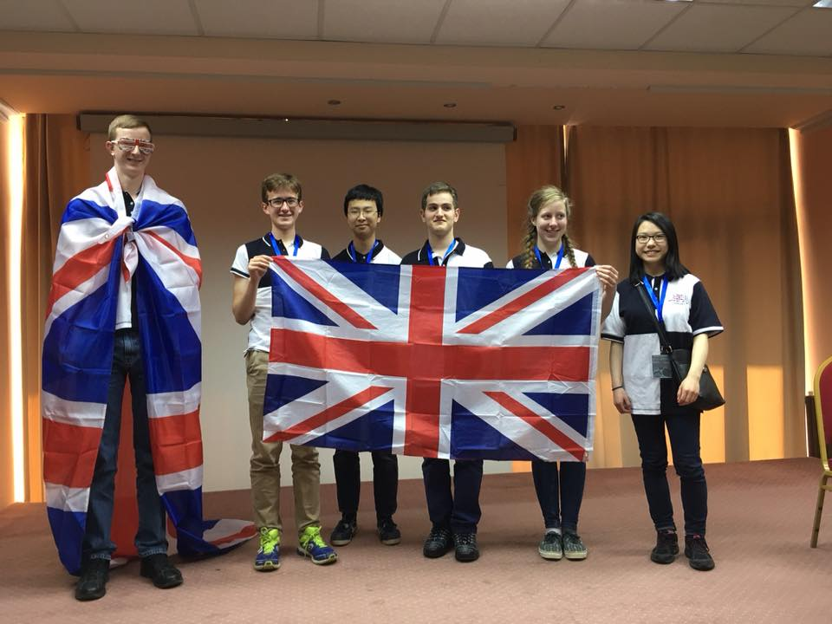
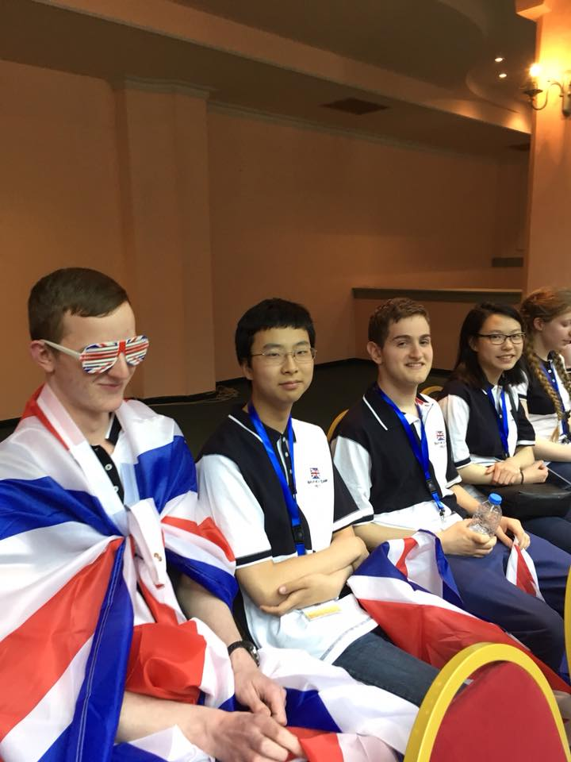
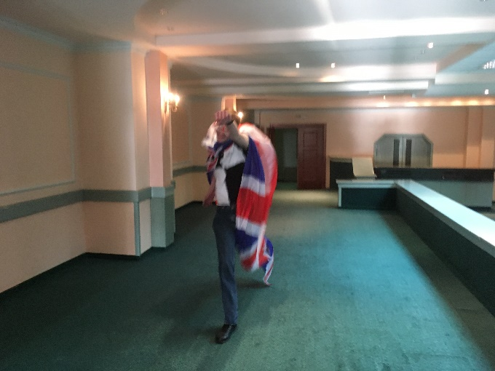
Day 0
We all met up at the Ibis Hotel at Luton airport on Monday evening so we could all get at least some sleep before the early flight the following morning. After we had all arrived, we had tea in the restaurant before sitting down to discuss some hard puzzles from Dominic. The first challenge was to find the 6 countries whose names when spelt with capital letters contain no letter with any finite region that can be filled in. We got 5 countries and it’s debatable as to whether the sixth is actually a country. The problem developed into finding countries with letter that are invariant under inversion. By Day 2, Emily had come up with Togo and Latvia if we are slightly flexible with the shapes of our letters and allow infinitely big L's and T's.
After a discussion between Gerry and Dominic we decided that we would get up early to have breakfast in the hotel so we went to bed on the thought that we would have to be up at 6am the following morning.
Day 1
We all succeeded in managing to get up by 6:30 and having a bite to eat in the hotel before walking up to the airport.
The check-in process was fairly pain free apart from Gerry's kettle which seemed to cause quite a lot of confusion as to whether he was or wasn't allowed this in his hold luggage. Eventually he gave up and decided to take the kettle in his hand luggage.
Surprisingly, we all passed through security with none of us or our bags being stopped. Some of us headed straight to get a coffee to try and stay awake after the early get up and then we killed time round Luton airport for about an hour until we could go to the gate.
The flight passed surprisingly quickly and I wouldn't have really said it was 2 and a half hours long but I suppose this was a short time compared to the 4-and-a-half-hour exam that awaited us in Macedonia. Spare a thought though for Thomas (6ft 8 or just over 2m) on a flight with virtually no leg room!
The airport in Skopje is fairly small so by the time we got through passport control our bags were already on the carousel. There was someone waiting for us and the Italian team had been waiting in the airport café to travel to Ohrid with us in a minibus. Exiting the airport, it was surprisingly hot but there wasn't really time to enjoy the weather as we were straight on a 4-hour coach journey to Ohrid. Dominic bought us some sandwiches and pringles to eat on the way which was good as we hadn't eaten since breakfast.
We spent most of the journey discussing problems from past BMOs and other problems that Yuta had brought. The journey took around 4 hours as expected and we arrived in Ohrid around 7pm. Dominic and Gerry stayed on the bus to go to the leader's hotel in the centre of Ohrid. We were given our room keys and then we all headed up to our rooms looking forward to getting some tea. Hugo was in a room with 2 Bulgarians so we decided he could take the spare packet of pringles left from the journey as a peace offering. The arrangements were slightly weird in that there are 3 hotels attached to each other in a row that seem to be all part of one business. We arrived in the middle hotel and Jill was send to the hotel on the right and we were staying in the hotel on the left with the rest of the students.
Tea was good though not particularly vegetarian. Fortunately, Thomas ate fish which meant he could have something to eat more than potatoes and salad. We were all tired so we went to bed soon after tea. The rooms were well-equipped with towels, blankets and shower gel and the beds were reasonably comfy though I think we were all so tired I don't think any of us would have really cared.
Day 2
It was surprisingly cold when we woke up considering how sunny it had been the day before. We had free time up to the opening ceremony at 18:00 so what better way to spend the time than working through good maths problems! We started with some geometry as we could now retrieve our compasses that we'd had to put in our hold baggage for the flight. Then we moved onto working through more of the problems from past Balkan competitions.
After lunch, we met back up with Jill and went down for a walk to the lake which provided a nice break from the maths. The water from the lake was really clear and we could see lots of small fishes moving around in the water. We had an attempt at stone skimming but fairly quickly reached the conclusion that we were all pretty terrible. When another team decided to start skimming stones further along the lake we realised how bad we were and decided it was time to move on. The weather had clouded over after we left the hotel but it was still surprisingly warm outside. As we were going back, Hugo pulled off his disappearing trick where one minute he would be there and then he would vanish and we'd meet up with him again later. This would become a recurring theme throughout the trip.
We returned to our rooms to get our UK T-shirts which we all thought were quite nice and that the black and white pattern was better than some of the colours that had been picked in past years. Dominic had brought multiple UK flags and Thomas decided he would wear the massive flag as a cape and put on his UK sunglasses which gave everyone a good laugh.
We briefly got to see Dominic and Gerry again at the opening ceremony though we couldn't speak to them as they had been working hard that day to select the problems for the competition. The ceremony was surprisingly short but it meant Jill had time to take some photos before tea. Thomas also took the opportunity to try out his new GB cape!
After having tea, we all wanted to get a good night's sleep before the exam so we headed off early to bed trying to quell the nerves for the exam the following day.
Day 3
Thomas, Yuta and I, managed to slightly underestimate how much time it would take to get sorted in the morning and had ten minutes to wolf down some breakfast before we went into the exam (the others were far more organised).
I won't say much about the problems on the exam other than that we generally though it was a good paper with some interesting problems. Dominic has written an interesting summary going through the ideas and motivations of each problem for those who are interested. There was a general murmur among some of the other teams that the paper had been found comparatively easy compared to previous years and as a result we were expecting the medal boundaries to be quite high.
We were all glad to get into lunch after the exam and have a break from maths. Gerry and Dominic didn't expect the paper to start on time so turned up at the hotel about 45 minutes after the exam had finished. We were glad to see them as we hadn't seen them for the two days they'd been in the leaders’ hotel.
Figure 1 Opening ceremony
Figure 2 Thomas' Cape
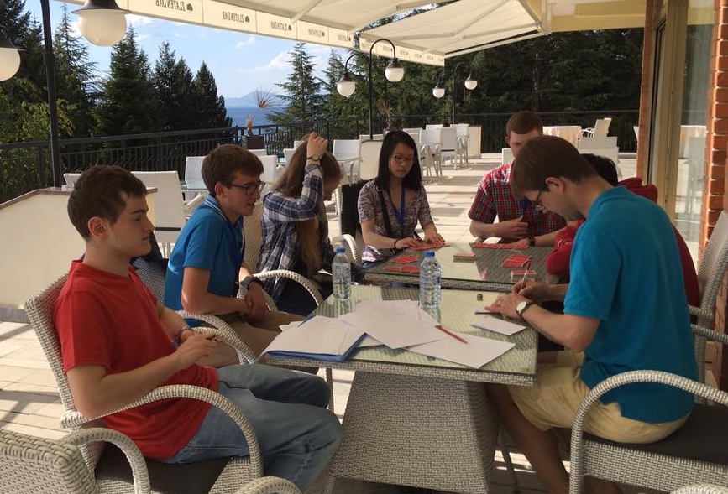
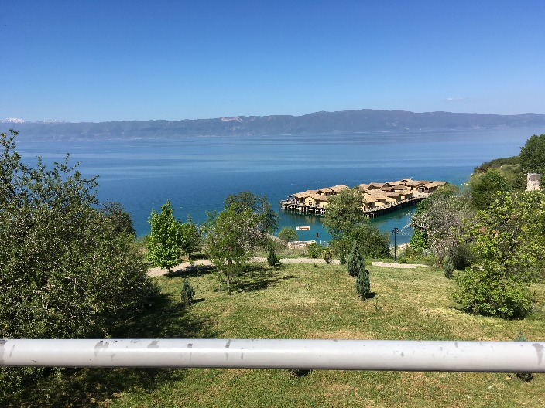
We had some free time with Gerry and Dominic before they were whisked away to start marking. Dominic taught us a new slightly weird card game where you hold your cards so that you are the only person who can't see your cards. It's quite good and we enjoyed it and we got a bit better after our first round which was a complete disaster.
The frantic photocopying of our scripts was finished for about 6 so Gerry and Dominic went off to start marking. We went back for a walk down to the lake. It was a lot choppier than it had been when we went before but surprisingly there were a lot more people out fishing so we decided that stone skimming probably wouldn't be a good idea.
After we'd had tea we enjoyed chatting and being a bit more relaxed now the exam was over and we just had sightseeing to look forward to. We also took advantage of the exam being over to stay up late as it no longer really mattered if we were a little bit tired. Yuta and Thomas had a couple of goes at playing blindfold chess and unsurprisingly found it rather difficult. We decided we'd make it more interesting by saying that making an illegal move meant you lost the game but this just reduced to them moving one piece backward and forwards to avoid making an illegal move.
Emily and I decided to head back to the rooms where everyone seemed to be in a party spirit. When it got to gone midnight though we started to wonder where Yuta, Naomi and Thomas had got to (Hugo had already pulled off his disappearing act by this point). We returned downstairs to find they were still sitting waiting for someone who had challenged them to a chess game about 2 hours earlier. Yuta had started creating a list of useful theorems for BMO 1 and 2 (the British one's that is) but it quickly became more like a book as we had to create a new list for imaginary BMO 3 so we could add areal coordinates, Hölder's inequality and the law of quadratic reciprocity to the list. Me and Emily tried heading back to the rooms again hoping to get some sleep tonight; this time we succeeded in bringing Thomas with us.
I'm not sure exactly what time it was but it must have been around 2 o'clock in the morning when Yuta and Naomi finally came back up having decided that 4 hours was a bit long to wait for someone from one of the other teams to come back to play a chess game. This certainly meant Yuta had volunteered to get up and have first shower in the morning.
Day 4
Yuta took getting up to having first shower a little bit seriously getting up at 7:15 despite us not having to be ready for the excursions until 9 o'clock. Even with Yuta's early get up, we managed to be even later for breakfast than the day before when we'd got up a lot later. By the time we arrived, Emily and Naomi were already there. We quickly grabbed a bowl of cereal in about 5 minutes to rush outside in order not to be late for the excursions.
We met Jill outside before boarding the coach for the day’s excursions. Gradually other teams trickled onto the coach, tired from the previous night’s partying. We drove for half an hour until we arrived at a place called the 'Bay of the Bones'. The site was a reconstruction of a stone age settlement that had been discovered preserved underneath the water in Ohrid Lake. It consisted of many huts constructed using traditional methods on a raised wooden platform that had been built out into the lake where the site previously would have stood. After that we headed back up to the coach and set off again.
The next place we visited was the monastery of St Naum which was an ancient building dedicated to a saint who had lived around Lake Ohrid. We managed to lose the tour guide while heading up to the monastery but we were all quite happy to wander around and explore ourselves. All around the grounds of the monastery there were a lot of peacocks walking around. We were debating peacocks flying abilities when one duly answered our question by flying a sizeable distance from the top of a lamppost into a tree. They are certainly not the most elegant birds in the air but they most certainly can fly.
We timed our entrance to the monastery perfectly as our guide was just about to commence her talk. After she had explained the surprisingly well-preserved frescos inside we exited to allow another tour group to enter. It was then free time for the rest of the afternoon to explore the grounds of the monastery.
Figure 3 Dominic teaching us a new card game
We had another go at stone skimming on a different part of the lake and seemed to find much more success; certainly more than the previous attempt. We also stopped to have ice creams which we were pleasantly surprised to all be priced less than 100 Macedonian Denar (a bit less than £1.50).
Figure 4 Bay of the Bones
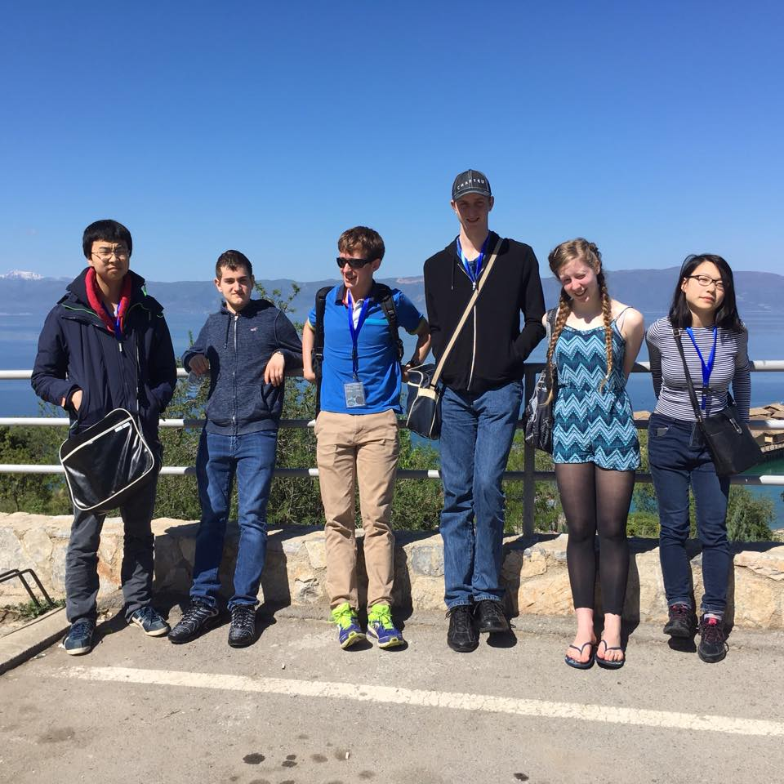
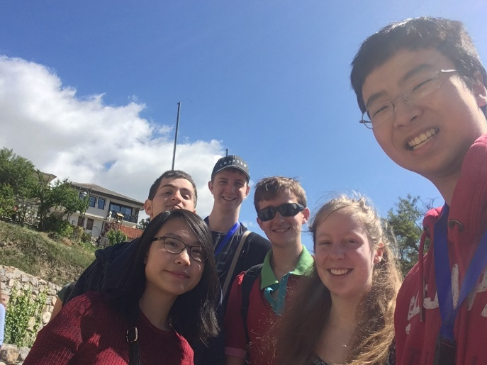
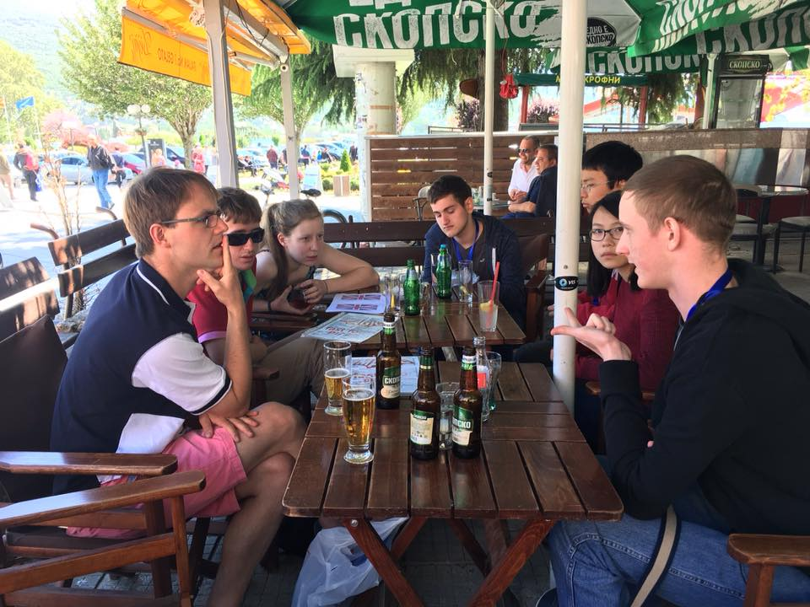
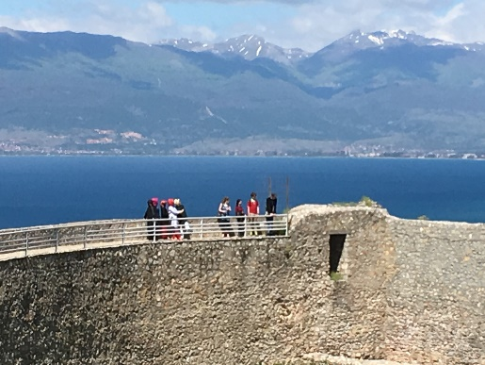
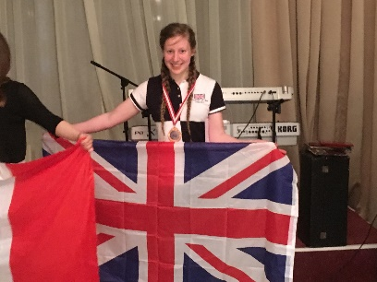
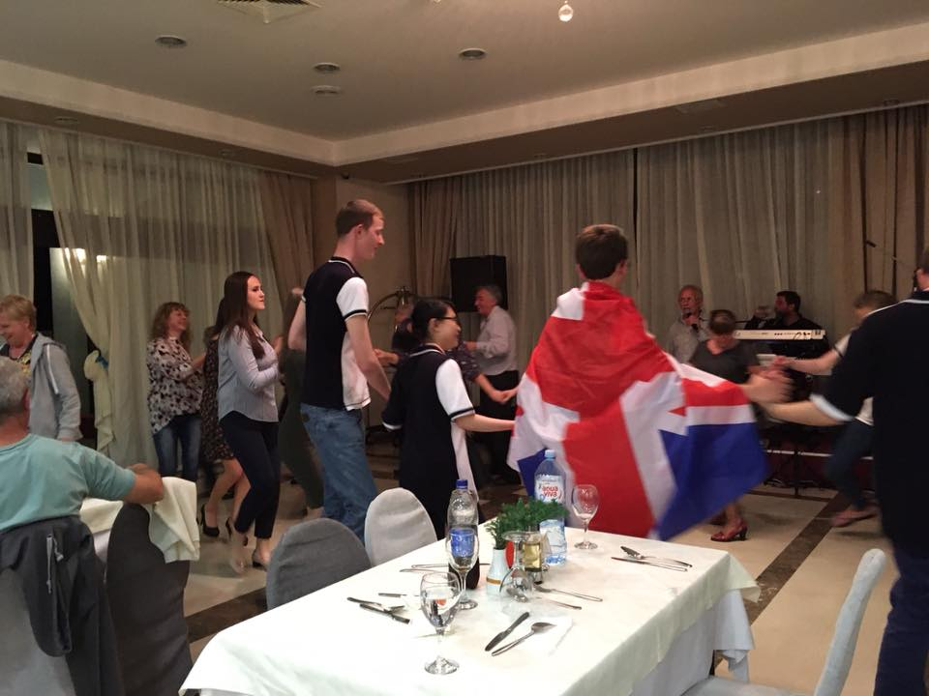
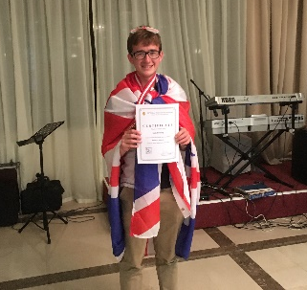
After returning to the hotel we had lunch and then started playing some of our newly learnt card games to try and pass the time. Thomas had come up with a slightly ridiculous rule for Mao which involved making a compliment towards Silouanos every time a heart was played. Initially this was quite amusing but it became increasingly ridiculous as the evening went on. We were all quite anxious as we knew Gerry and Dominic were in meetings with coordinators deciding what marks we would receive on the exam. Despite this the time seemed to pass quite quickly and soon it was around 18:00 and Dominic and Gerry returned with the marks.
After we had received the marks we were told that the medal boundaries would be decided in a jury meeting later that evening. Based on what other teams had said about the paper we knew the silver boundary would probably be 31 or higher which meant that no member of the team would receive a silver medal however the bronze medal threshold was a lot more uncertain. When Dominic returned from the first jury meeting and said he thought the bronze medal threshold would be around 16 we were all slightly surprised but in a pleasant way as it meant 4 members of the team would be receiving a bronze medal. It took until 10 that evening for this all to be finalised but it meant we all now knew what we had got and could truly relax and enjoy the final day of excursions.
Day 5
We had to wake up reasonably early again for today's excursions with the coaches leaving the hotel around 9 o'clock. As usual Yuta Thomas and I met the others downstairs at around 10 to 9 giving 5 minutes to eat breakfast and 5 minutes to change some currency for Denars. We went out to the coach meeting Dominic, Gerry and Jill on the way then we set of into Ohrid.
The coach drove us to Ohrid town centre which was only 10 minutes away from the hotel. We were taken around the town by a very knowledgeable and interesting tour guide. We started off heading past the oldest tree in Macedonia which is around 1,100 years old (which is also a geocaching point that Thomas had been instructed by his dad to take a picture with). We then headed up through a woodland area in the middle of the town and ended up in a large, ancient theatre. We were told that the theatre has a capacity of around 3,000 and used to host gladiator fights though now is regularly used as a venue during the annual music festival hosted in Ohrid.
Continuing to climb, we headed up towards the fort that stood on the top of the hill in the centre of Ohrid. The fort and surrounding area had all been recently renovated thanks to a large investment project from the Macedonian government. The views from the top of the walls around the fort were amazing and you could get a view across the whole of Ohrid Lake.
We were glad that after this point the walk was all downhill. The final place we visited with the guide was the site of an ancient Christian Basilica. It was mostly all ruins but you could still see some of the original foundations and mosaics from the buildings. Also, there was a very impressive church. We discovered the church had been destroyed during the Ottoman empire and only the foundations remained so the church there today was in fact an architect's impression of what the original church would have looked like. All the same, it was a very impressive building. We finished by going into a traditional paper shop on our way back into town where they make paper using the same machines they used hundreds of years ago. The shop is one of only two in the world still preserving these historical techniques. This also was an opportunity there to buy souvenirs to take home which some of us took advantage of.
After we had finished there, we returned to the town centre where we were given a couple of hours’ free time. Armed with our Denars, we set off to the shops. We started off going into Ramshop which was a supermarket in the centre of the town. We all bought a combination of drinks and snacks which we’d missed during our stay. We then headed down what appeared to be the main shopping street where we bought the obligatory touristy fridge magnets to take home.
On the recommendation of our tour guide, we met back up with Dominic, Jill and Gerry to have lunch in the 'Magic Restaurant' on the main square. The food, mostly pizzas, was good and fortunately was served just quick enough that we had time to get an ice cream before heading back to the coach. This was quite fortunate for me as I had earlier strongly advocated waiting until after lunch to have ice cream and the thought of having to return to the coach without having had them didn't seem to go down too well with the rest of the team.
After we got back to the hotel, we quickly settled back into card games having had yet another game suggested by Dominic which helped to pass the time. At 18:00 we all went back to our rooms and put on our Balkan T-shirts in preparation for the closing ceremony which was due to start at 18:30. I also donned the cape which Thomas had worn at the opening ceremony as we had made a bet that the highest scorer would wear it to the closing ceremony. When we returned downstairs with the cape in tow, Jill told us that the closing ceremony had in fact been moved to 20:00 and was in the other hotel which made us look slightly silly for having made such a big deal of our walk down.
Despite having got ready for 18:30 we still managed nearly to be late for the closing ceremony starting at 20:00. Due to us being a bit late, there were only tables left for 8 but in true British fashion, Hugo got on with moving the tables and chairs around so we had a table for 9 ignoring the confused expressions from the onlooking waiters.
After we had got something to eat, the Macedonian leader and competition organiser gave a short speech and then the medal presentation began. Yuta was on official photography duty which was quite a challenge as there wasn't much space at the front of the hall where everyone wanted to get a photo with their flag and medal. When we go to onto the silver and gold presentations, a group of probably over 30 adults on the far side of the room jumped up and started cheering for some students. We initially thought it was the Macedonian team but actually the Bulgarian team. We weren't too sure whether it was just coincidence that a Bulgarian tour group happened to be in the hotel or if they had come specifically for the competition. Either way, the Bulgarian team had performed exceptionally well receiving four gold medals and were more than deserving of the support.
After the medals had been awarded, the music and dancing started. We went outside so we could get some photos of the whole team. The Greek and Albanian teams were outside as well so we got photos with them as well. We then returned into the hall where the folk music and dancing was now in full flow. After a little persuasion from Jill, we decided to go up and give the folk dancing a try. It was certainly a lot harder than it looked. Initially we were all pretty clueless but Emily seemed to get the hang quite quickly and the rest of us at least managed to get a vague idea of when we were going forwards and backwards. The songs go on for a surprisingly long amount of time and by the time the song finished we were all hot and sweaty. The Macedonians all seemed impressed that we had joined in even if, excepting Emily, we were all terrible at it!
Figure 5 Picture at the Bay of the Bones
Figure 6 UK Team selfie
Figure 7 Dominic giving us another hard problem to think about
Figure 8 Old fort with Lake Ohrid in the background
Figure 9 You can just about see Naomi getting her medal
Figure 10 Showing I made good on the bet!
Figure 12 Emily getting her medal
Figure 13 Our attempt at folk dancing
Figure 11 Hugo knows how to celebrate!
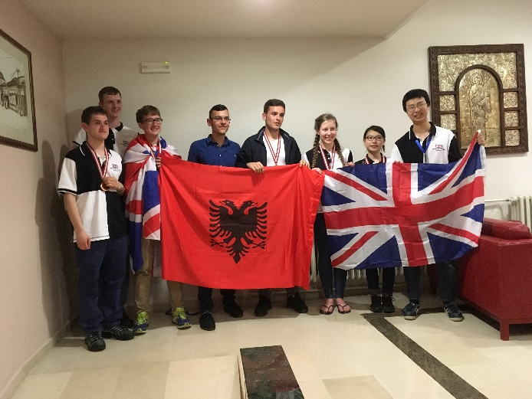
Dominic taught us another card game similar to Jungle Speed for those who have ever played that but with a normal deck of cards. Initially we tried improvising using a pack of tissues as the object in the middle but this was quickly mangled by slightly over-aggressive grabbing. We found that some of the plant life from a vase on the table was much more robust and worked a lot better. As the evening went on, we were joined by members of the Greek and Cypriot team which required getting another deck of cards for everyone to play. One member of the Greek team was rather too good at the game winning it at least three or four times and receiving an increasingly large pile of cards from everyone else each time he joined back in to try and slow him down. Gradually other teams headed off to bed which was probably a sensible idea given at this point it was gone 11. After exchanging Facebook accounts, we headed back up to the room. Fortunately, an Albanian walked back to our hotel with us as we didn’t really know the way around the outside because we couldn’t go through the hotels due to a wedding going on. The Albanians had a 3-hour coach journey back so didn’t have to get up until 10 o’clock in the morning but our coach was due to leave at 6:30 so we had to go back and pack. By the time Yuta, Thomas and I had finished packing and chatting we checked the time and realised it had already gone 2 in the morning. This wasn’t our most sensible idea given that we had to get up at quarter to 6 the following morning but we would have plenty of time to sleep on the coach and plane journeys.
Figure 14 Picture with the Albanians

Day 6
After getting up at quarter to 6, we finished packing our bags and then headed out of our rooms meeting Emily and Naomi outside. We were all slightly confused where Hugo was but when Yuta returned saying he wasn’t downstairs we realised he must still be asleep. At this point it was already 6:30 so we went into Hugo’s room and found him fast-asleep. Amazingly, he managed to get dressed and out of his room in under 5 minutes and we still left by about 6:40.

We were joined again by the Italian team for the journey back to the airport. I can’t say much about the journey because I spent most of it asleep as the lack of sleep had certainly caught up with me. When I woke up, we were within about a half an hour of the airport and there was only time for me to join in a couple of rounds of one card Indian poker which was probably the easiest card game to play on the coach. As we left the coach at the airport, Emily came out with a medal that had been dropped on the coach. After a bit of rustling in bags, I realised I had wrapped my medal in my waterproof which I had then decided to use as a pillow on the coach and the medal must had dropped out. It was fortunate that someone picked it up otherwise that would have been a bit of a disaster.

We said goodbye to the Italian team then headed into the airport. The airport was pretty small so ended up having breakfast in Burger King. Our breakfasts consisted of chicken nuggets and onion rings which is slightly peculiar but we were all starving so didn’t mind.

The flight to Budapest went quickly. Most of us managed to get through passport control okay but Yuta and Naomi had problems. Dominic waited with them while the rest of us took the bags to check-in and went through security. We grabbed some pizzas, water and some sandwiches for the others once we’d got through security. The prices were certainly a big change from the cheap prices we’d got used to in Macedonia! As it got nearer and nearer to the flight taking off, we were all concerned about where Dominic and the others had got to. Fortunately, as we boarded the busses to go to the plane, Dominic appeared with Yuta just in the nick of time. They had missed check-in but Dominic had managed to negotiate it so they could still take their hold baggage on the plane. Once we got on the plane, we were reunited with Naomi and we could all relax after a slightly stressful couple of hours.

We arrived in London Luton slightly earlier than expected at about 4:50. Boarder control was quick and our bags were there by the time we got through. After saying our goodbyes, I left with Gerry to board the train to London from which I was getting the train back up to Warrington which was due to get back about 9:15 making it a very, very long day indeed. I think we all enjoyed getting home and getting a good night’s sleep to a least be mildly recovered for going to school the next day.

Acknowledgements and Thanks
On behalf of the team we would all like to thank Gerry, Jill and Dominic for their hard work throughout the competition which allowed us all to have a great time. We would also like to thank the Macedonians for putting on an excellent competition and organising the excursions to allow us to explore the wonderful country. Also, all the countries participating in the competition did a commendable job in speaking English to allow us to communicate which makes a massive difference. Finally, we’d like to thank UKMT for funding the flights, everything we needed during the trip and for providing us with team T-shirts. Thank you for taking the time to read this report. I realise it is considerably on the long side but I assure you it looked shorter when I originally wrote it on my phone!

Balkan Memes
Here is a list of memes that Yuta compiled throughout the camp ranked from best to worst:
- Silouanos
- Areal bash
- Disappearing Hugo (/the other Hugo on the train)
- Fewer not less
- Fouuuuuur
- Profiteroles
- Captain Brexit
- Inverting to oneself
- Mental chess
- Pikachu
- Rejected peace offering/Pringles

I think this report is already long enough for me not to use any more words explaining them all but I was instructed by the rest of the team that I must include the list in the report. I’m sure you can have some fun trying to find the significance of them all.

The 6 countries are CHILE, FIJI, LIECHTENSTEIN, SEYCHELLES, YEMEN and NIUE (which is a small island off New Zealand which has autonomous rule; I’m still not convinced!).
I would tell you the rules for this card game but that would be breaking the rules so unfortunately I can’t
Since giving a talk at the Trinity Camp, Silouanos seems to have become a slightly unhealthy obsession amongst some members of the UK team.
The Macedonian Denar seems to be a rather elusive currency that is almost impossible to get in the UK so you have to change Euros or Dollars when you arrive in Macedonia.

